**Summary:**

This document contains a list of the issues and solutions that were required to get docker working on my windows computer. Some issues were not resolved, such as fbprophet install, even after many hours of troubleshooting. I decided in the end not to spend anymore time troubleshooting and instead complete my code on my anaconda environment on my computer which too took a long time of troubleshooting to get fbprophet package to work.

**Issues:**

1. Pystan + FBProphet packages would not install correctly throwing multiple errors:
   1. Example of such error can be found in error.txt in this subdirectory
   2. Solutions tried:
      1. Apt-get install of gcc
      2. Apt-get install of python-dev and python3-dev
      3. Installing various supporting packages (plotly, pystan) at different previous versions
2. Had issues with my WSL 2 where I was unable to get the build to work from Command Line nor Powershell with the following error:
   1. Building the container and tagging it forecasting_take_home.  
      The command 'docker' could not be found in this WSL 2 distro.  
      We recommend to activate the WSL integration in Docker Desktop settings.
   2. I believe this has to do with the shell environment on my computer not recognizing the docker command. I have a few theories on how to fix this but after 10+ hours of troubleshooting all issues, I moved on to working on the assignment.
      1. Theories: Need to add in a few lines of code to the ~/.bashrc file to recognize docker. This would be in my mind analogous to adding in environment variables to PATH within Windows.
   3. Solution: I instead used cygwin64 which I use as my linux emulator which would successfully build using the ./driver.sh file provided
      1. 
3. After building and starting jupyter notebooks on the docker instance, through Cygwin, it would not show all the files located in the folder forecasting_take_home
   1. 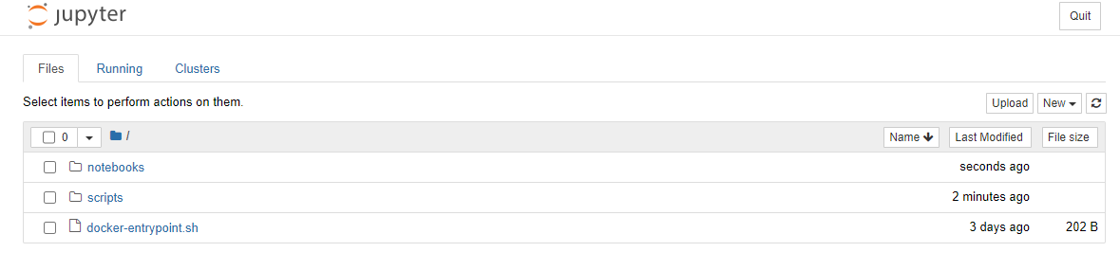
   2. 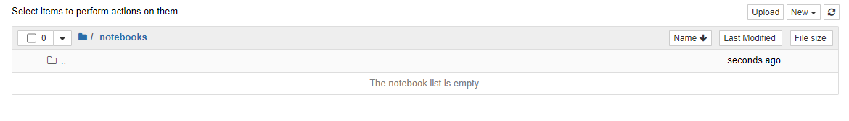
   3. 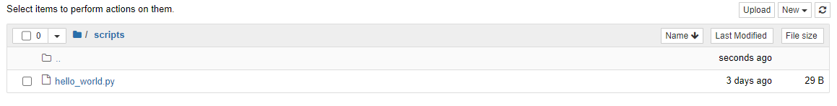
   4. Solution (a): I attempted to find the directory the files needed to be in but instead found that I can upload files within Jupyter so I uploaded them manually.
   5. Solution (b): I also found that if I removed the line that attached the volume to the docker image it would then recognize all images within the subdirectory that I built the container from.
4. Inability to stop containers via command line:
   1. Error:
      1. /cygdrive/c/Users/colby/Documents/forecasting_take_home

$ bash driver.sh stop

Stopping the forecasting_take_home container.

"docker container stop" requires at least 1 argument.

See 'docker container stop --help'.

Usage: docker container stop [OPTIONS] CONTAINER [CONTAINER...]

Stop one or more running containers

* 1. Solution:
     1. I was required to call ‘bash driver.sh docker-clean-all’ in order to stop containers.
     2. On my first iteration of this project before troubleshooting the issues with FBProphet I was able to stop and start containers via command line but this ability stopped upon altering my Windows environment.

1. Inability to get FBProphet/Pystan to work in my Anaconda Environment:
   1. Solution: I was required to troubleshoot the issue finding the solution to run the following command in my Anaconda environment to get the packages to work (which I found on stackoverflow):
      1. conda install -c conda-forge fbprophet
      2. I assume that this is doing some sort of repair or revert to older compatible packages

**Conclusion:**

In conclusion I attempted to reinstall and reconfigure docker, WSL 2, and Cygwin (Linux emulator) multiple times on my computer in order to get the docker container to work. After a respective amount of time had passed I made the decision that you as the hiring team would not want me to spend all of my time trying to get it to work and instead move on to the analysis of the data. I am sure with more time I can get it to work or could find resources to assist with such issue. I hope that this compatibility issue, which I suspect is due to my Windows environment, does not hinder my ability to be considered a candidate for the position.